**Cloud Computing: UE20CS352**

**Assignment 3: Introduction to AWS**

**-Adithya M, Section K**

**-PES1UG20CS621**

**In Lab 1:**

Screenshot 1a: Bucket Creation

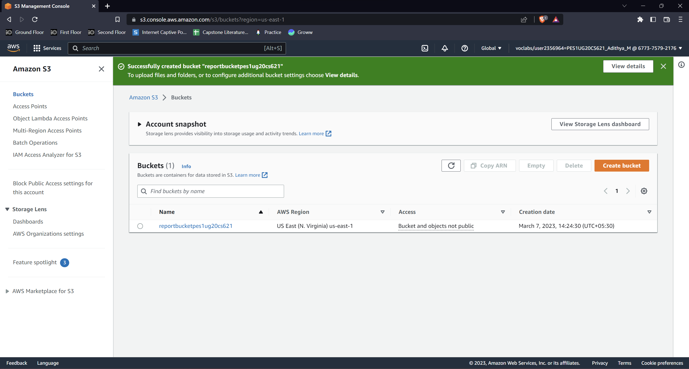

Screenshot 1b: Access denied error when opening new-report.png

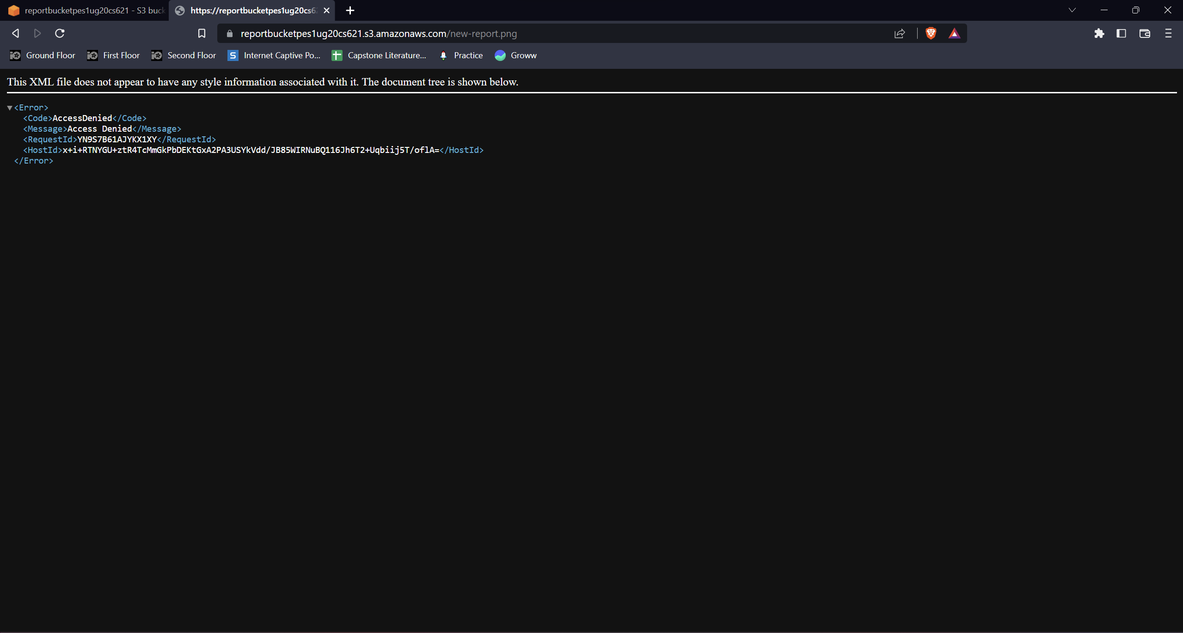

Screenshot 1c: Display new-report.png after making it publicly accessible

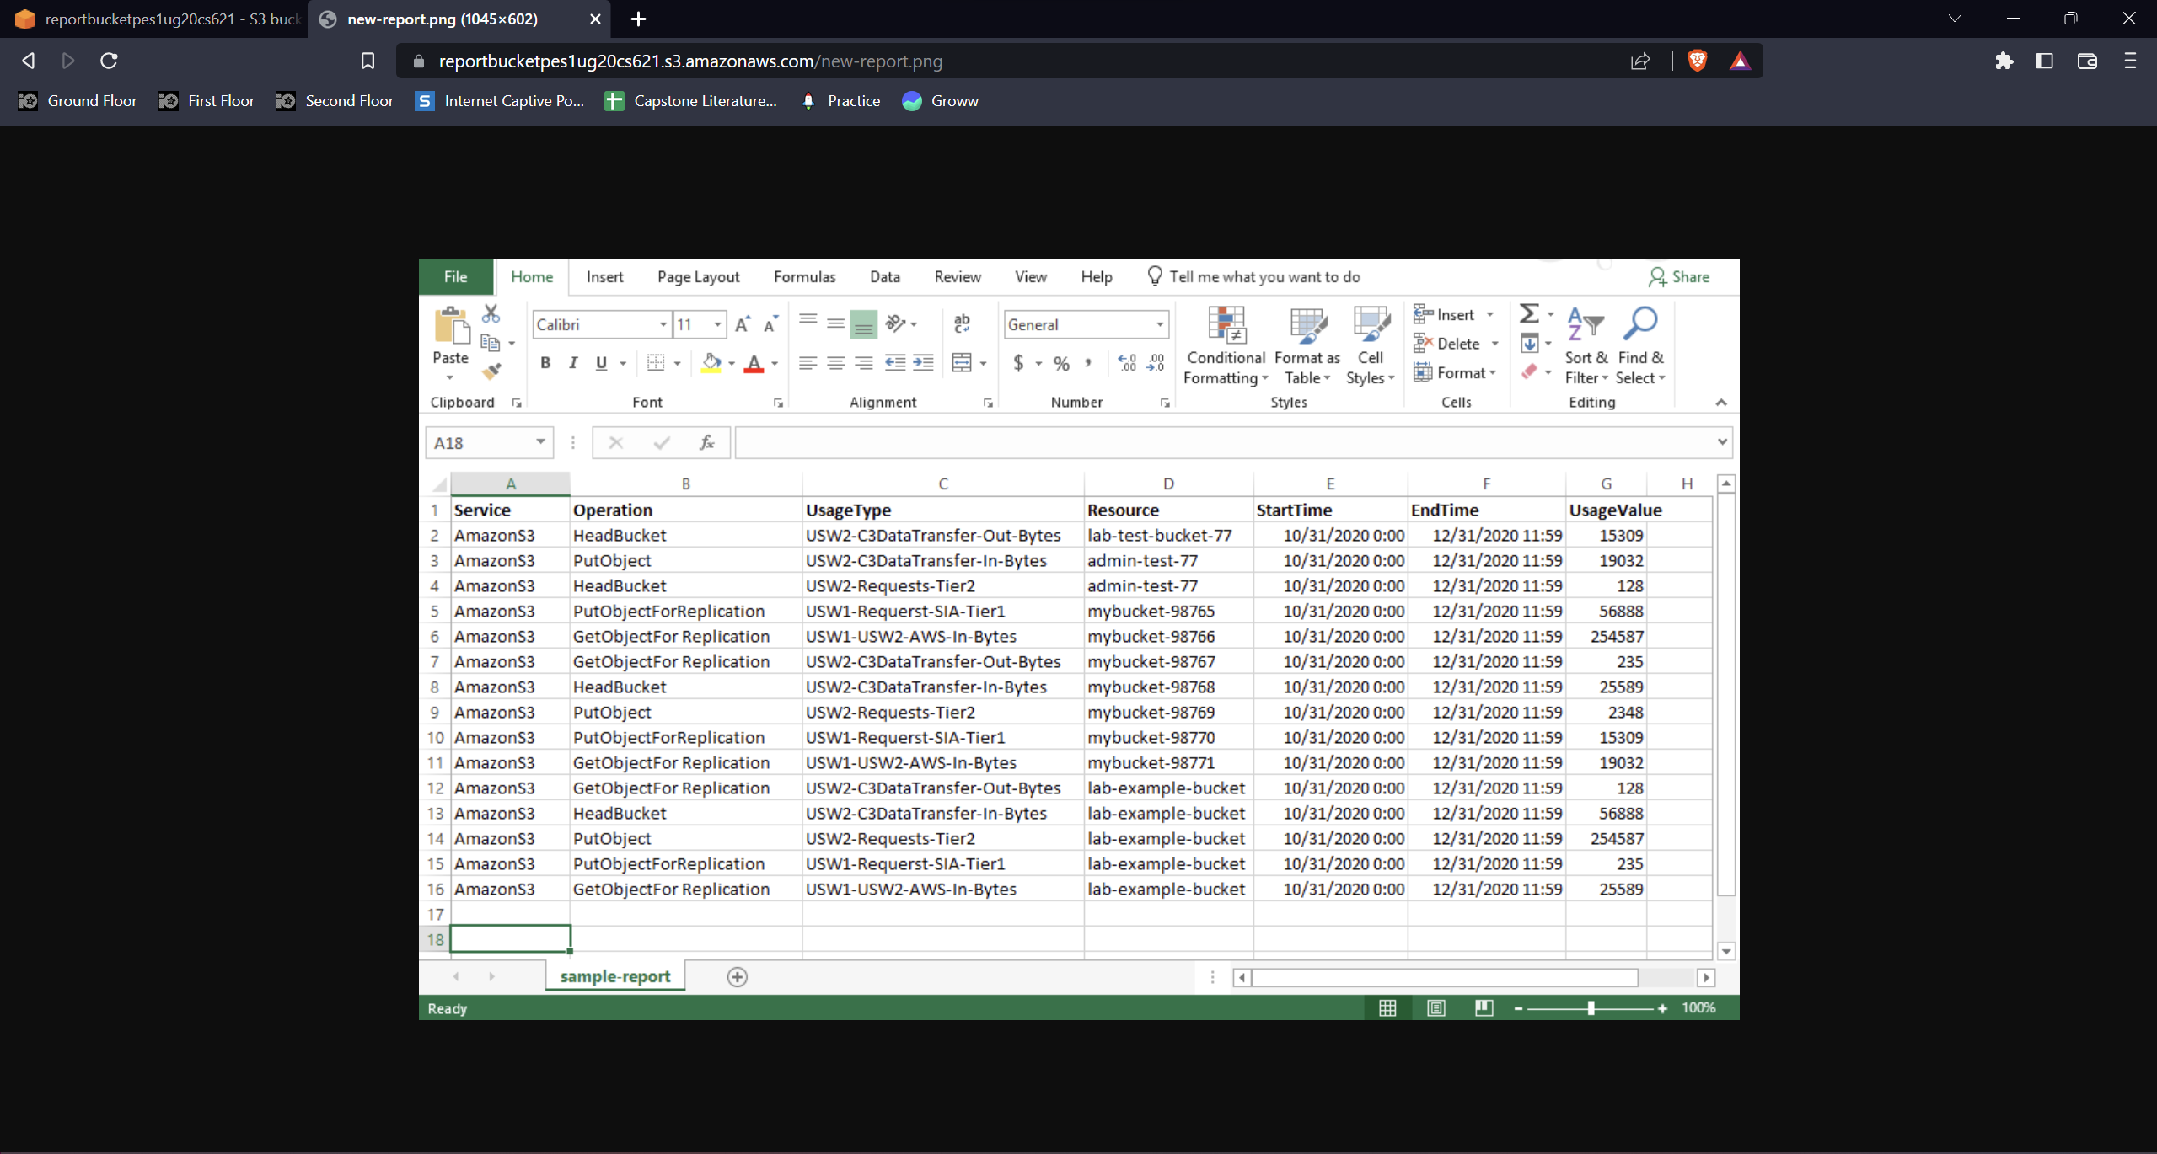

Screenshot 1d: PutObject operation failed (Access Denied)

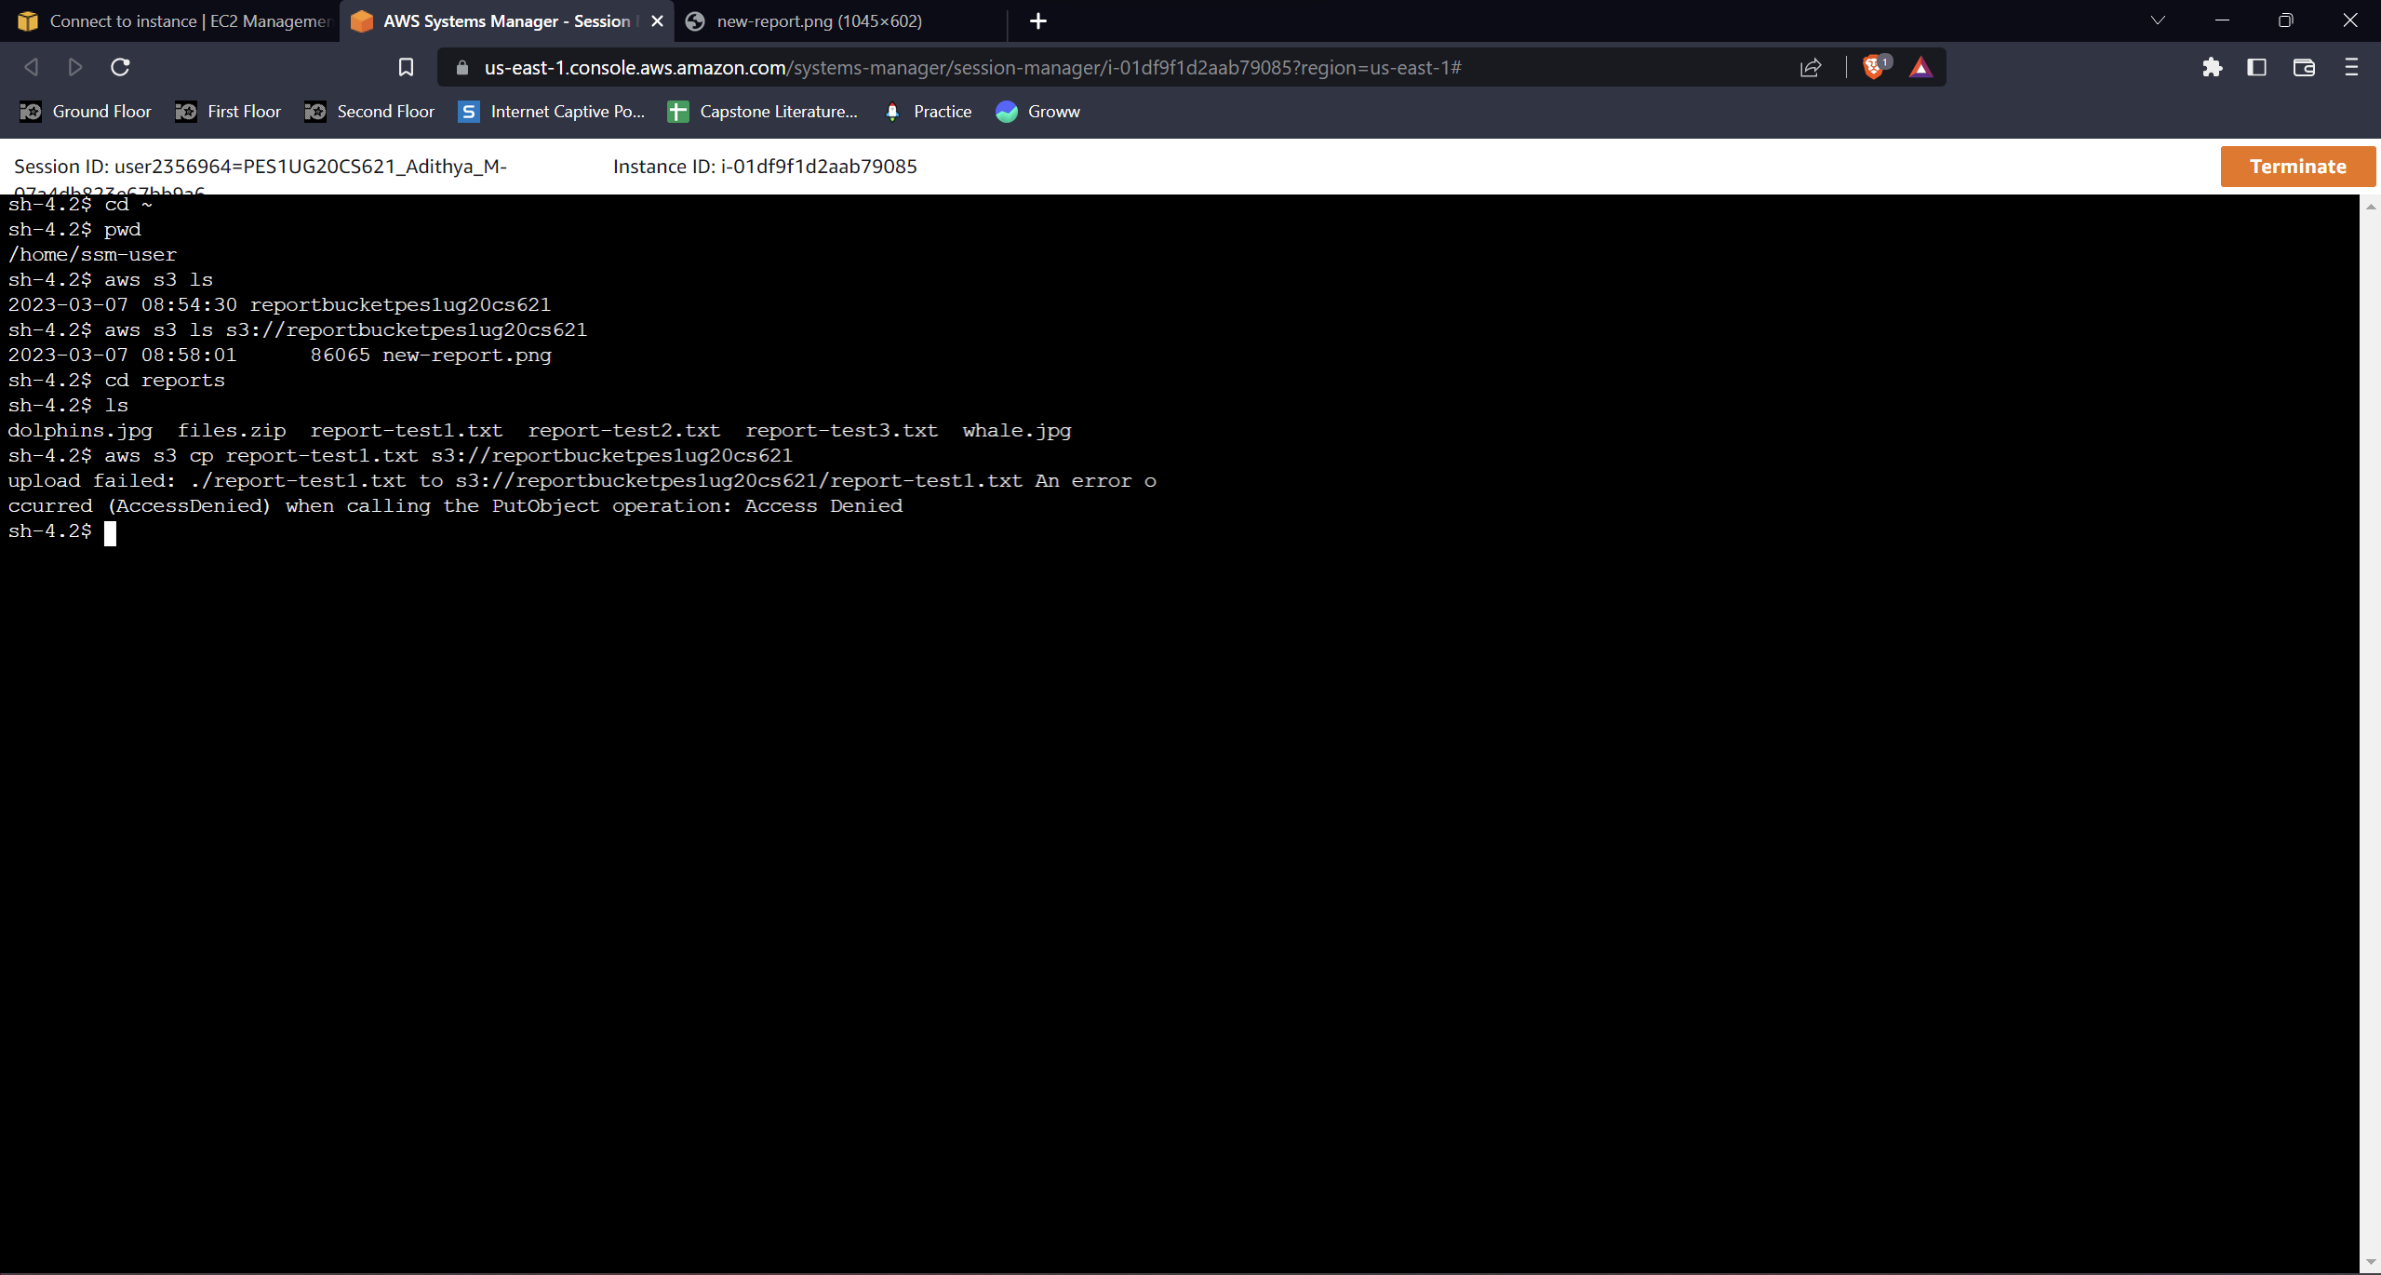

Screenshot 1e: Access denied error when opening sample-file.txt

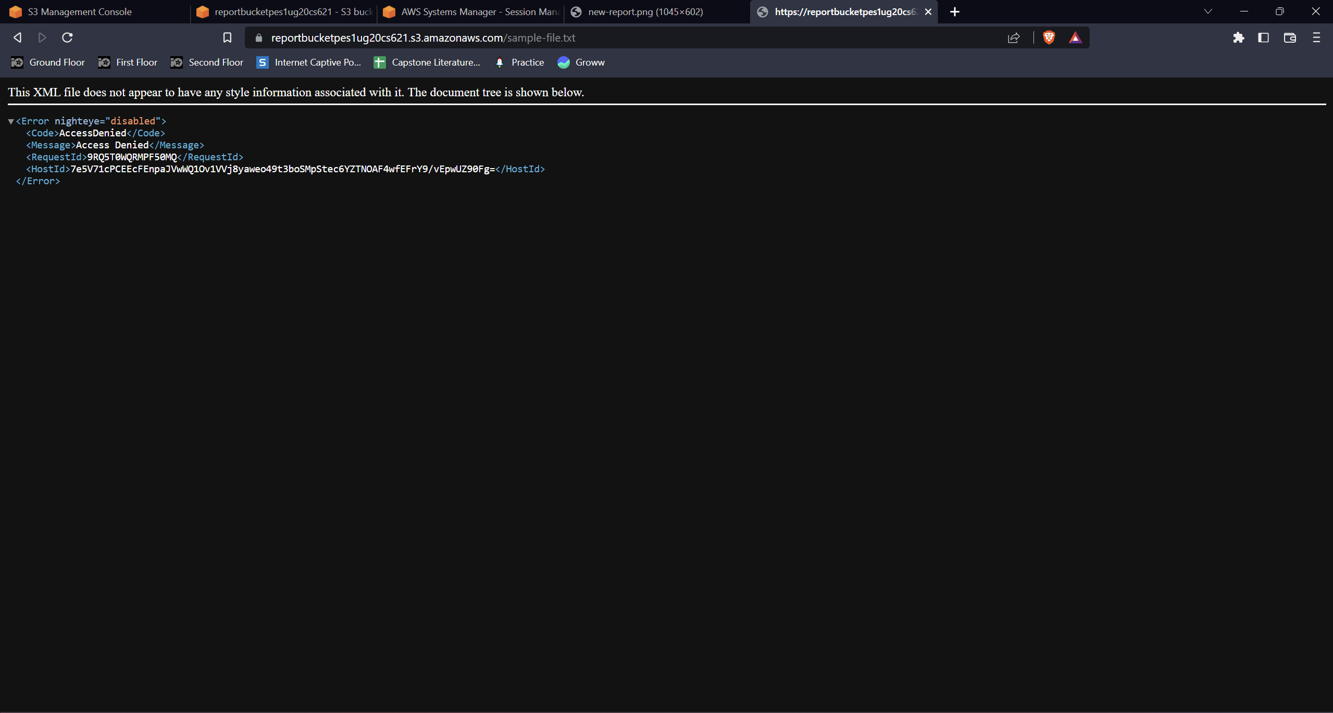

Screenshot 1f: Display sample-file.txt after updating policy

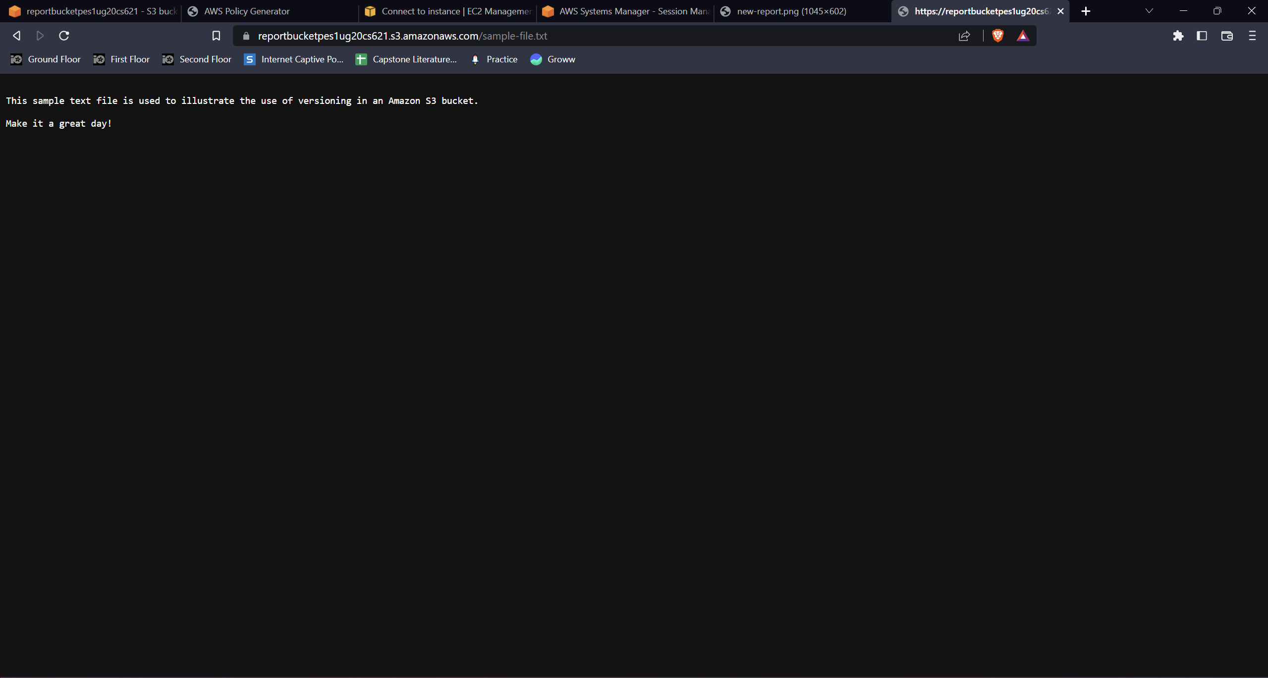

**In Lab 7:**

Screenshot 2a: Enabled static website option selected under “Edit static website hosting”

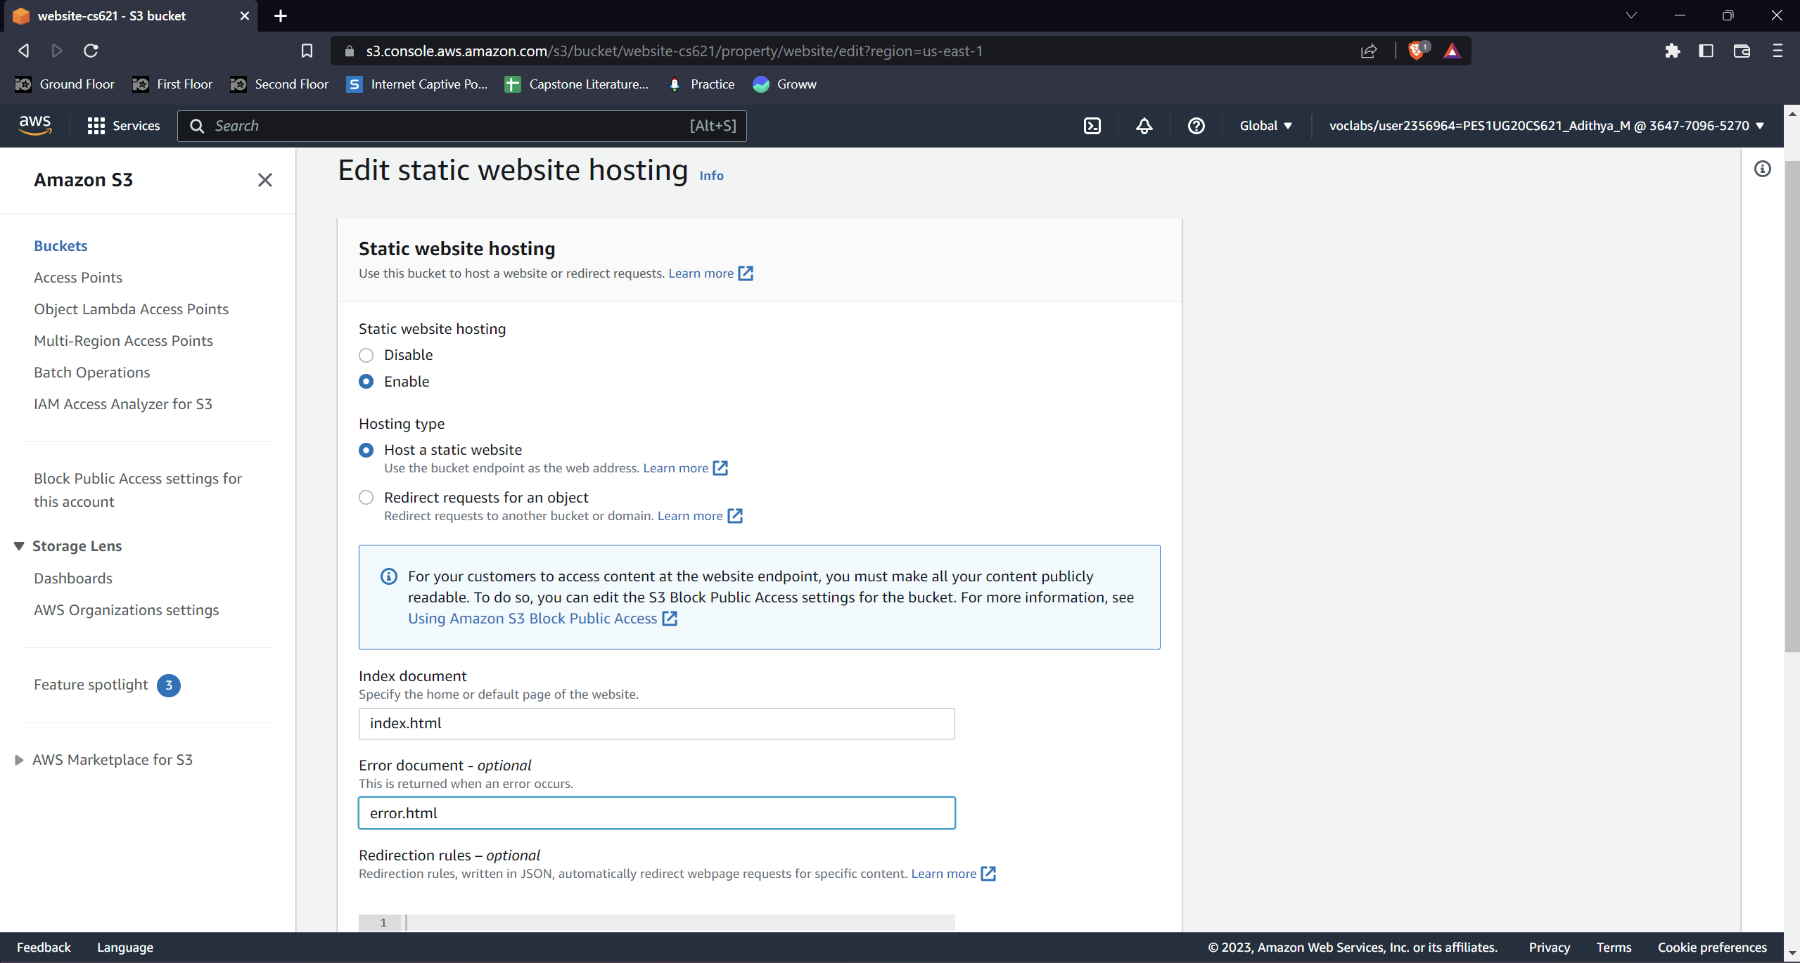

Screenshot 2b: 403 Forbidden Error page

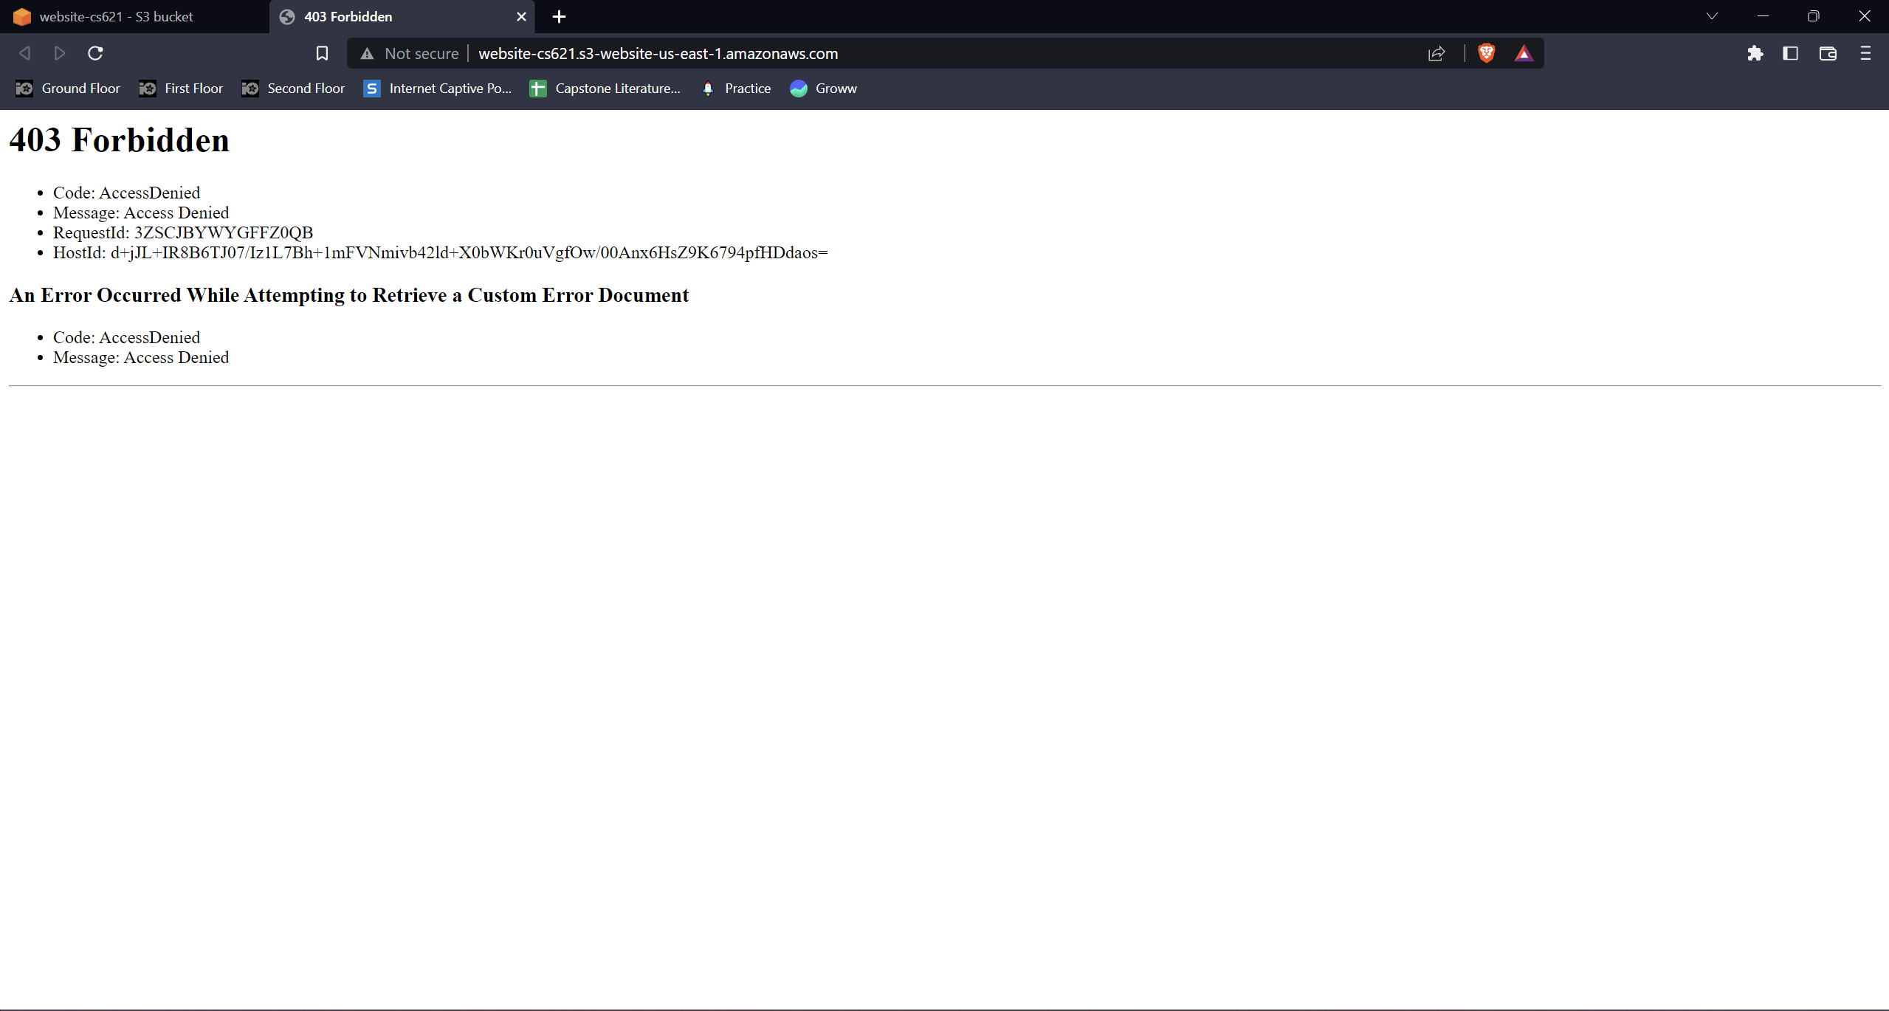

Screenshot 2c: Uploaded objects (index.html, script.js, style.css)

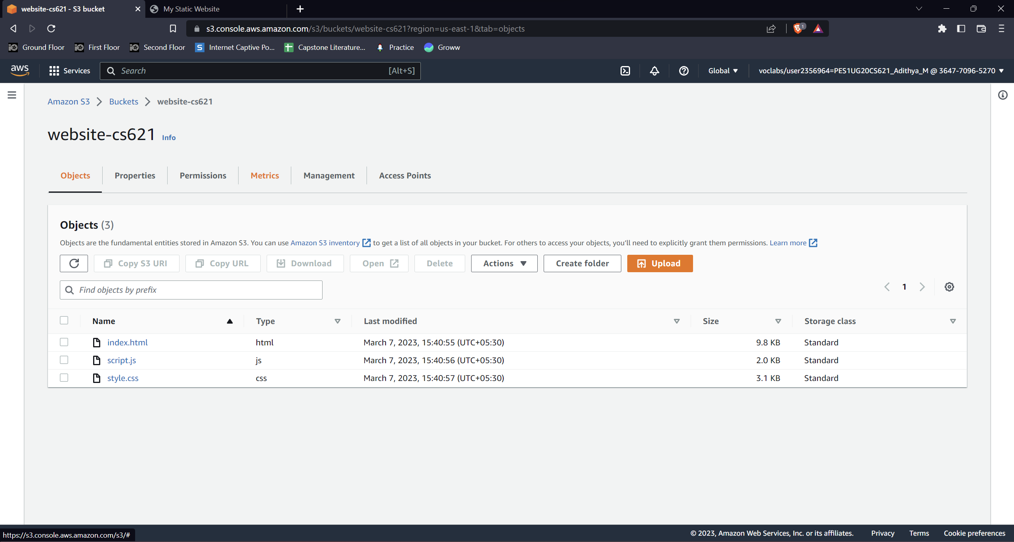

Screenshot 2d: Static website before modifying index.html file

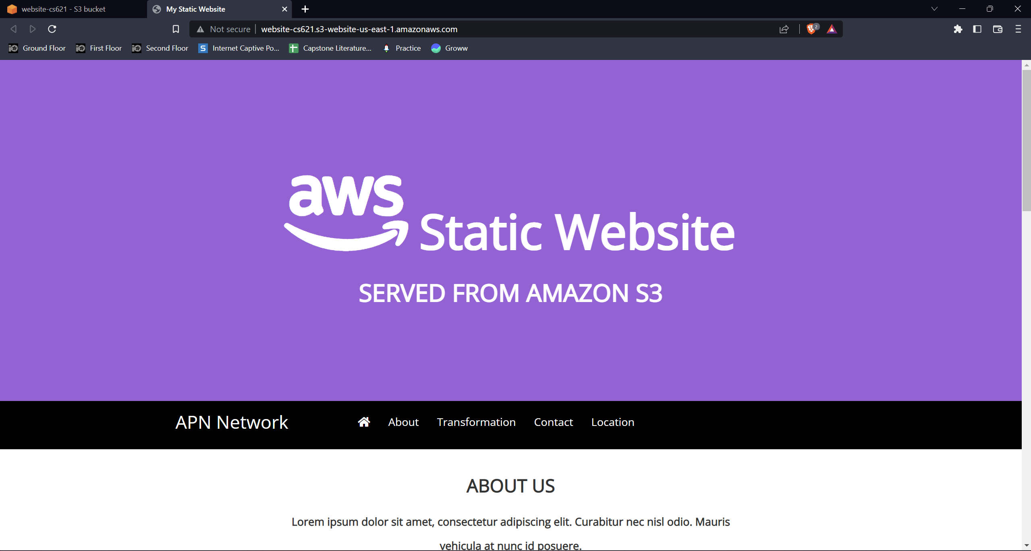

Screenshot 2e: Static website after modifying index.html file

